**SPS results**

**Introduction**

SPS reports are organized to reflect the hierarchical nature of the results, in the following areas:

* Input spectra: A set of spectra read from MS/MS device produced files.
* Clustered spectra: similar spectra are clustered and a consensus spectrum is defined. The clustering process determines which spectra are grouped together.
* *Contigs*: Consensus spectra that are related to the same protein are grouped together. Then an overlapping algorithm builds a contiguous large spectrum (*contig*) based on the grouped consensus spectra.
* Proteins: one or several *contigs* may map to one protein. The identified protein, along with the identified protein sequences, are shown.



Report structure

**Project results**

The report’s initial page, ***index.html***, contains a summary and links to access the various report areas. General information, which include job name (Job), user who submitted the job (User), current report generation status (100% means the report is fully generated and can be viewed), and the time needed for report generation.

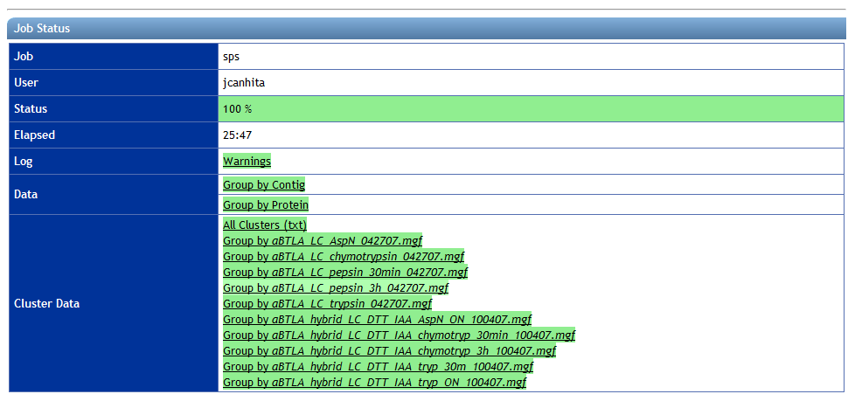

Report’s initial page

The ***Log*** section provides access to the report generation engine log file, where warning messages related to SPS internal works are displayed.

Through the ***Data*** section, the user may view directly the identified proteins or the generated *contigs*. Going further into the report hierarchy, clusters and spectra data may be accessed in context.

The ***Cluster Data*** section allows the user to access directly to generated clusters of spectra, and subsequently to the spectra associated with them.

**Proteins**

The ***Group by Proteins*** section contains the list of identified proteins. The table, as shown below, contains, per each protein, its name, a brief description, the number of *contigs* and spectra that lead to its identification, the number of matched amino-acids.

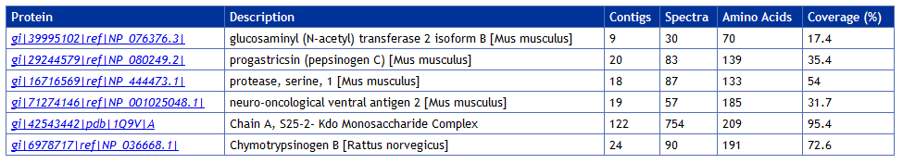

Protein list

Selecting a protein, specific protein information is accessed. At the top of the page the protein's name can be found, as well as the number of *contigs* and spectra that lead to its identification, the number of matched amino-acids.

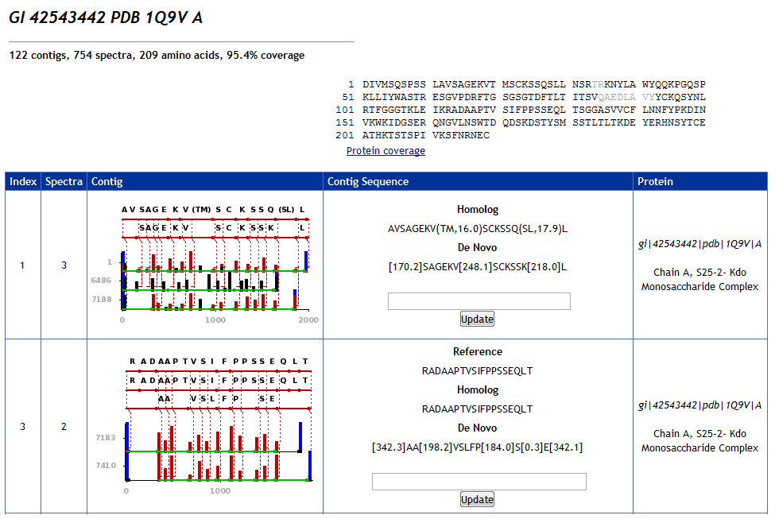

Protein page

The protein sequence is shown, with the identified amino-acids displayed in black and the not identified in gray.

Further down the page, the *contig* list associated with the protein, where each row corresponds to one *contig*. Each column contains (from left to right) the *contig* index number, the number of spectra used to generate the *contig*, the *contig* image, the *contig* sequence and the protein associated with the *contig*.

In the *contig* sequence column there is the homolog sequence and the **De Novo** sequence. The edit box allows the user to specify its own sequence and modify the report according. This functionality allows the user to specify a sequence and perform the mapping to the spectrumin context.

Clicking on one of the *contig* images, information about the *contig* itself is accessed.

**Contigs**

The *contig* information page shows, at the top, the *contig* image. The table below contains the homolog spectra used to produce the *contig*.

In each row, from left to right, are shown the spectrum index number, the homolog peptide spectrum image, the peptide sequence, the peptide mass, charge, the percentage of Y and B ions and the signal intensity.

In the peptide column the homolog peptide sequence and the De Novo sequence are shown, and an edit box that allows the user to specify its own sequence and modify the report according. This functionality allows the user to specify a sequence and perform the mapping to the *contig* in context.

In the Spectrum column, if the image is clicked it is amplified. Below the spectrum image, the ***Cluster*** button opens a page containing cluster information.

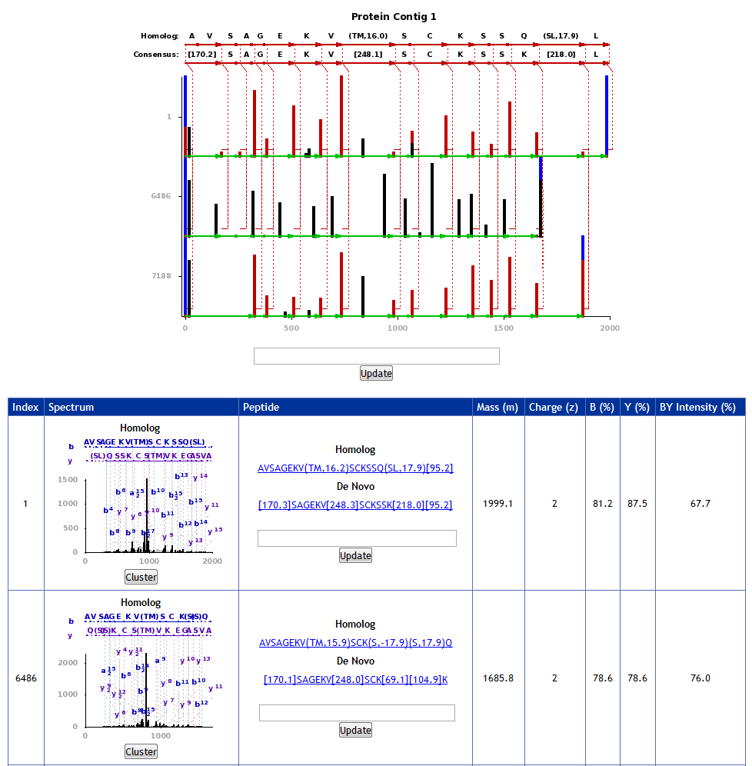

Contig

**Clusters and Spectra**

The clusters section displays information about the cluster of spectra groups together to identify the consensus spectrum, further used to generated *contigs*.

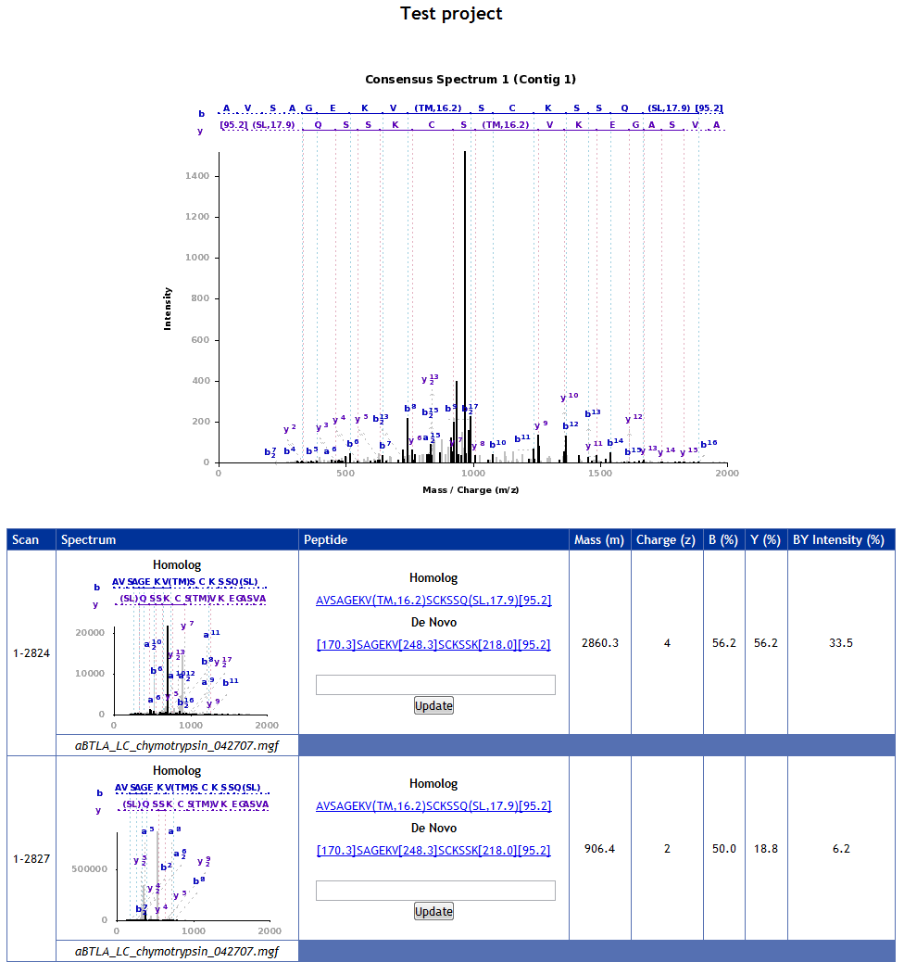

Clusters

At the top of the page, the consensus spectrum is shown. Below, the table contains the spectra list that was clustered together.

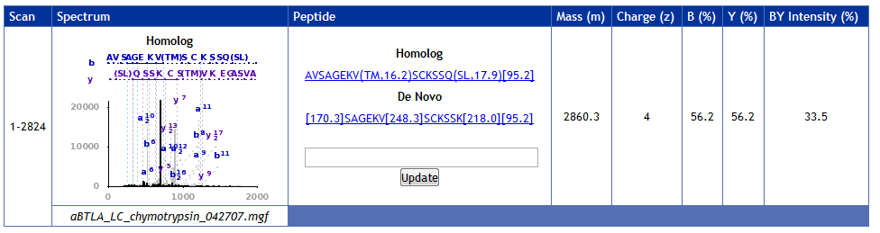

Spectrum details

In each table row we can see the scan range for the spectrum, the spectrum image (which can be amplified if clicked on), the peptide sequence, its mass, charge, percentage of B and Y ions and its intensity.

**Protein sequence**

In the protein report page, at the top, under the protein sequence, the user may access the detailed protein sequence showing the mapped *contigs* by following the Protein coverage link.

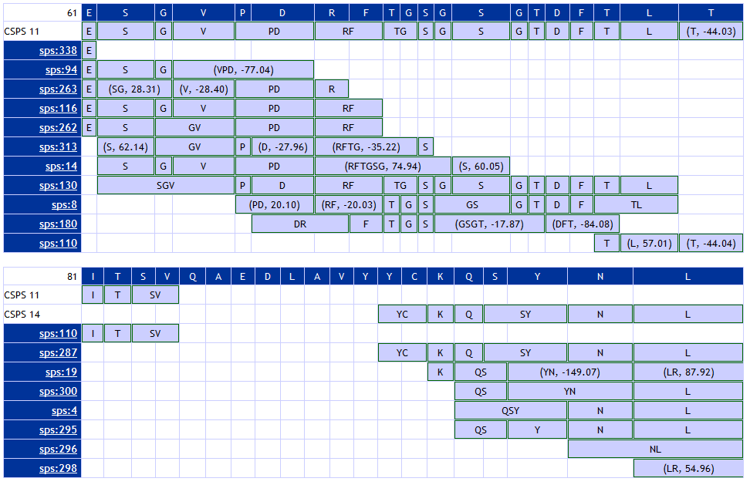

Protein coverage

The protein coverage page contains the protein sequence (shown in dark blue) and the *contigs* that were mapped to it shown in light blue. Each box around an amino-acid or around a group of amino acids means that it corresponds to a single spectrum value (mass value). If the amino acid (or group of amino acids) mass differs from the mass value, it is shown inside brackets with the mass difference.

Below the protein are shown the ***csps contigs***, which are larger *contigs* generated from sets of *contigs* that overlap, and are identified on the leftmost column by “csps” followed by its index number.

In this examples are shown two groups of *contigs* (csps *contigs*) generated from two sets of *contigs*, which then are mapped to the protein.

**Interactivity**

As stated earlier, SPS allows specifying an amino-acid sequence to map to a *contig* or spectrum in context. This functionality works by sending back the specified sequence by the user to the server and rebuilding the report files by the server, which means that some time (from a few seconds to a few minutes, depending on report size and server load) is needed. After, a page refresh is needed to clear the browser cache and reload the modified page.